


Name: Muhammad Shahrukh
CNIC: 42501-5440822-5
Contact No: 0318-5595230
Program: Blended International IT Trainings (BIITT 2026)
Course: IBM Full‐Stack JavaScript Developer Professional
Center: Viper Technology Innovista Indus IT Park – DHA Phase 2 Ext Karachi
Student Details Search System
- Objective
The objective of this program is to create a console-based application using Node.js that allows a user to search for a student by name. Upon finding the student, the program displays their complete academic details, calculates their total and average marks, and uses a Nested If-Else structure to determine their age status (Adult/Minor) and grade.

- Code Explanation (Define / Logic)

Component | Technical Explanation
Importing Readline Module | const readline = require("readline"); imports Node.js's built-in module to read input from the standard input (keyboard) and output to the standard output (terminal).
Creating Interface | rl.createInterface() sets up the input/output streams so the program can interact with the user via the terminal.
Data Storage (Array of Objects) | A constant array named students holds 3 objects. Each object represents a student with specific keys: name, age, course, assignment, quiz, and finalExam. This acts as our in-memory database.
User Prompt | rl.question() displays the message "Enter student name: " and waits for the user to type a name and press Enter. The input is stored in the inputName variable.
Search Logic (Case-Insensitive) | The .find() method iterates over the students array. The toLowerCase() method is called on both the student name and the input. This ensures the search is not case-sensitive (e.g., "shahrukh" matches "Shahrukh").
Conditional Check (If-Else) | <ul><li>If condition: Checks if foundStudent is undefined (i.e., no match found). If true, it prints a "not found" error message.</li><li>Else block: Runs when a student is found.</li></ul>
Calculation Block | Inside the else block, total is calculated by adding assignment, quiz, and finalExam marks. The average is calculated by dividing the total by 3. The .toFixed(2) method formats the average to exactly 2 decimal points.
Output Display | All the student details, along with calculated total and average, are printed to the console using template literals (backticks).
NESTED IF-ELSE (Core Logic) | <ul><li>Outer If: Checks if the student's age is >= 18. If true, prints "Adult Student"; if false, prints "Minor Student".</li><li>Inner If (Nested): Inside both the Adult and Minor blocks, there is a second level of conditions. This nested block checks the average marks. If average >= 80, it prints "A+"; if >= 70, it prints "A"; otherwise, "B".</li></ul>
Closing Interface | rl.close() terminates the readline interface gracefully after processing the input, preventing the program from hanging indefinitely.

- Output Snapshots (Series-wise Results)
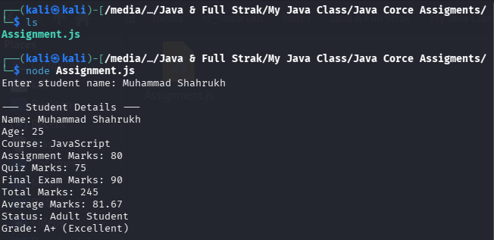

Input: Muhammad Shahrukh
expected Output: Age 25 (Adult), Grade A+ (Average 81.67)

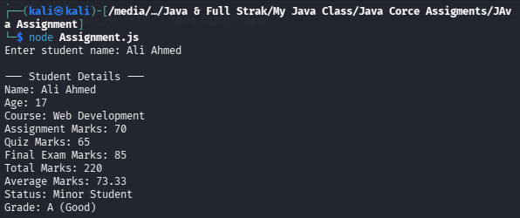

- Input: Ali Ahmed
Expected Output: Age 17 (Minor), Grade A (Average 73.33)

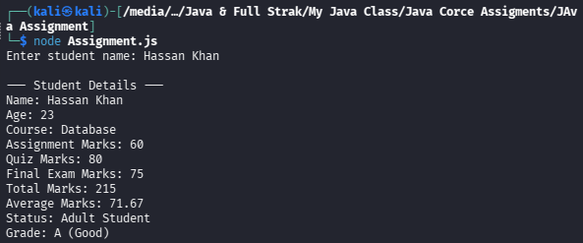

- Input: Hassan Khan
Expected Output: Age 23 (Adult), Grade A (Average 71.67)

- Execution Steps (How to Run the Prototype)
- Open the terminal (Kali Linux / Windows CMD / macOS Terminal
- Navigate to the directory where Assignment.js is saved
- Run the command: node Assignment.js
- The terminal will display: Enter student name
- Type any name from the dataset (e.g., Ali Ahmed) and press Enter.
- The terminal will print the complete student details, total, average, status, and grade.

- Conclusion
In this assignment, we successfully created a functional console-based prototype using Node.js. The program effectively demonstrates
- Data structures (Arrays and Objects).
- User interface (Readline module)
- Search algorithms (Array .find() method)
- Decision-making using Nested If-Else statements, where the outer condition handles age classification and the inner condition handles grade calculation based on average marks

The attached screenshots verify that the program outputs the correct, expected results for all given inputs.

